

**PET SHOP**

**Software Requirement Specification**

– Hanoi,April, 2023 –

**Table of Contents**

**I. Product Overview 4**

1. Introduction 4

2. Context diagram 5

**II. User Requirements 6**

1. Actor 6

2. Use case 6

a. High level use case diagram 6

b. Detail use case diagram 6

c. Use case list and description 7

**III. Functional Requirements 8**

1.System function overview 8

a. Screen Flow 8

b. Screen Description 9

c. Screen Authorization 9

d. Enhanced Entity-Relationship Diagram (EERD) 11

2.Manage account 12

a.Managed account 12

b.Add account 12

c.View account 13

d.Delete account 14

3.Manage cart 15

a.Create cart 15

b.View cart 16

c.Update cart 17

d.Clear cart 18

4.Manage orders 18

a.Managed order 18

b.Create order 19

c.View order 20

d.Update order 21

e.Cancel order 22

5.Manage personal profile 23

a.View personal profile 23

b.Update personal profile 24

6.Common feature 25

a.View home page 25

b.Register 27

c.Login 29

d.Logout 31

e.Forgot password 31

f.Product detail 33

g.Search 34

**IV. Non-Functional Requirements 35**

1.External Interface 35

a.User Interfaces 35

b.Hardware Interfaces 36

c.Communication Interfaces 36

2.Quality Attributes 36

a.Usability 36

b.Availability 36

c.Performance 36

d.Security 36

e.Safety 36

f.Support Documents 36

**V. Requirements Appendix 36**

1.Business Rules 36

2.Common Requirement 37

3.Application Messages List 37

**VI. Nhaps 38**

2. System Functions 38

a. Screen Flow 38

d. Non-Screen Functions 38

# I. Product Overview

## 1. Introduction

General information about the project:

* Animals are an indispensable part of our lives, especially domestic pets such as dogs and cats. Currently, the demand for dogs and cats is very high because in addition to guarding the house and furniture, they also bring many good benefits to the owner such as reducing stress to work more efficiently, bringing joy in life , improve the diseases of blood pressure and heart disease.
* Therefore, the system is expected to develop a website to trade animals namely dogs and cats to serve the needs of the market.
  + Group name: **Group 4**
  + Software type: **Website**

## 2. Context diagram

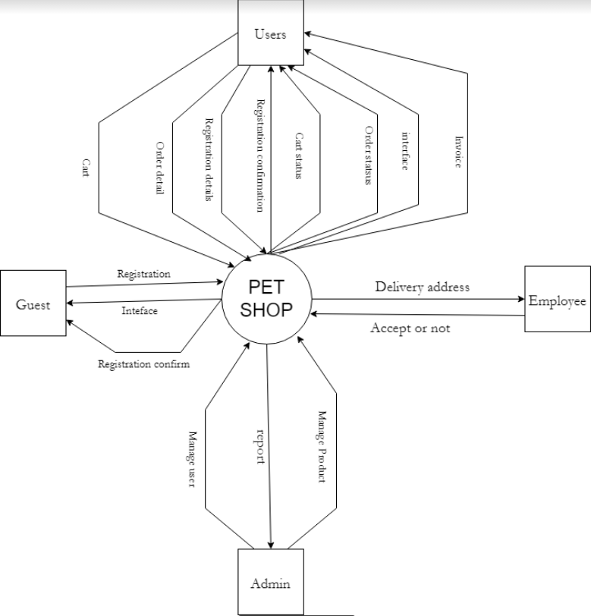

# II. User Requirements

## 1. Actor

| **#** | **Actor** | **Description** |
| --- | --- | --- |
| 1 | Admin | Person who is managing the whole system and accounts of everybody |
| 2 | Users | This actor represent **Customer** (who have an accounts and order products) or **Guest** (who don’t have an account) |
| 3 | Employee | This actor represent Shipper whom admin assign account |

## 2. Use case

#### a. High level use case diagram

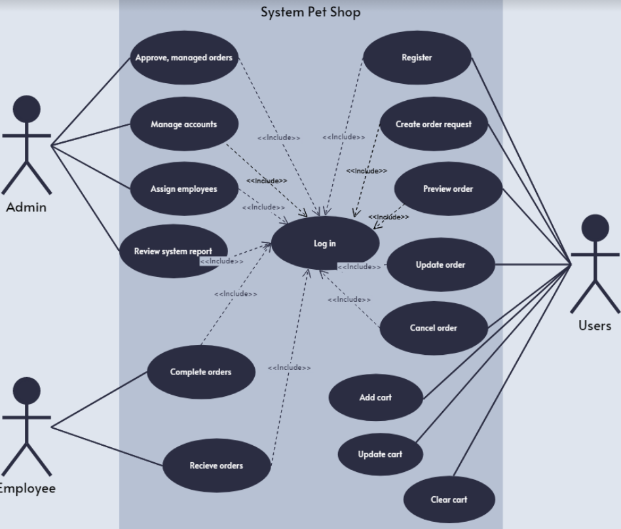

Figure ? : High level use case diagram

#### 

#### b. Detail use case diagram

#### c. Use case list and description

| **ID** | **Use Case** | **Actor** | **Description** |
| --- | --- | --- | --- |
| 1 | Managed account  (view,update,delete) | Admin | This function allows the admin to view, control all accounts in the system. |
| 2 | Assign employee | Admin | This function allows the admin to add a new account for employees (shipper) into the system. |
| 3 | Managed product | Admin | This function allows the admin to managed all product |
| 4 | Managed orders | Admin | This function allows the admin to accept and managed orders request |
| 5 | Review revenue | Admin | This function allows the admin to review the revenue each month |
| 6 | Receive order | Employee | This function allows employee (shipper) to receive orders from admin |
| 7 | Complete order | Employee | This function enables employees (shippers) to mark orders as complete when they have been successfully fulfilled. |
| 8 | Shopping cart | Users | This function allows users to add, view, update, delete  products to shopping cart |
| 9 | Orders request | Users | This function allows users to request orders when they logged in and want buy something |
| 10 | Update request | Users | This function allows users to update their request **(in condition)** and enable **only when logged in** |
| 11 | Cancel request | Users | This function allows users to cancel their request (in condition) and enable **only when logged in** |
| 12 | Register | Users | This function allows users to register a new account in the system |
| 13 | Login | Admin, Employee, Users | This function allows actors to access the system with their account |
| 14 | Logout | Admin, Employee, Users | This function allows actors to logout the system with  their account |
| 15 | Forgot password | Admin, Employee, Users | This function allows actors to set a new password if they forgot old password **(in condition)** |
| 16 | View home page | Admin, Employee, Users | This function allows the actors to view homepage |
| 17 | Search | Admin, Employee, Users | Searching by the product or category |

# III. Functional Requirements

## 1.System function overview

#### a. Screen Flow

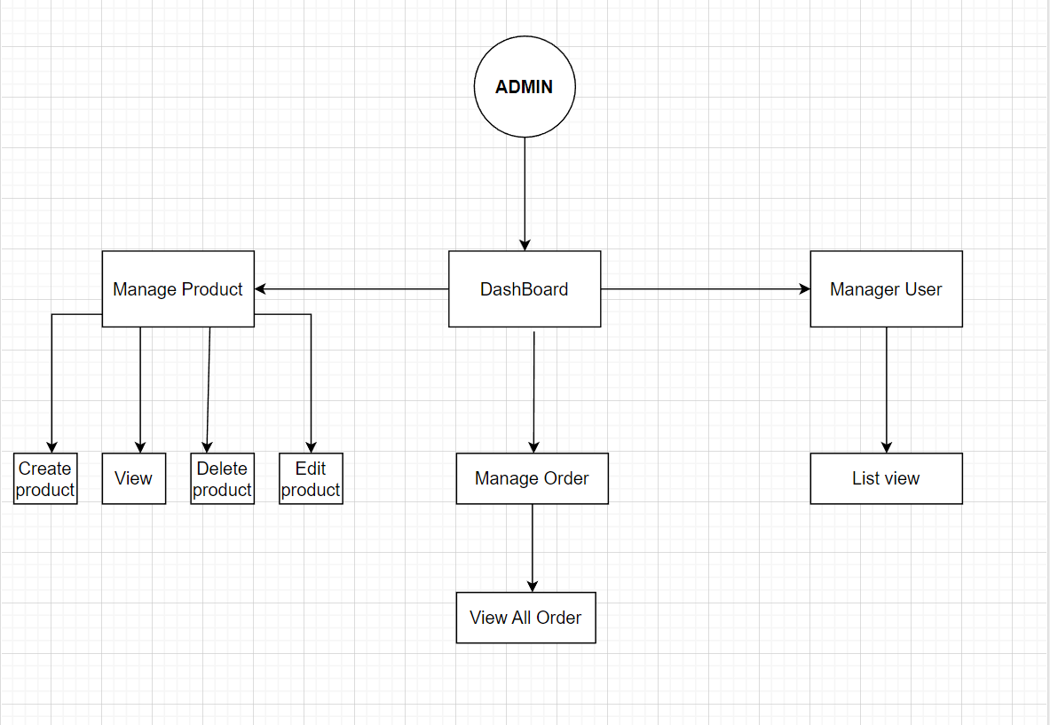

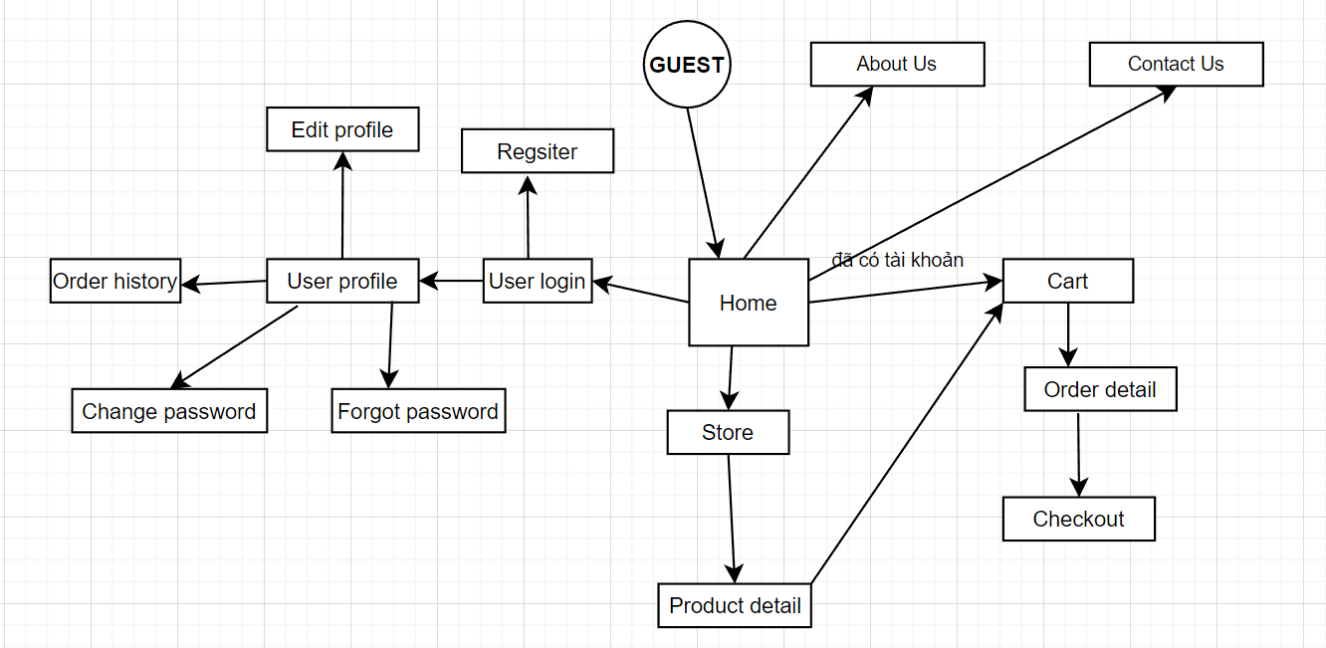

#### b. Screen Description

| **ID** | **Feature** | **Screen** | **Description** |
| --- | --- | --- | --- |
| 1 | Managed account | Managed account | Display all accounts to managed on managed side |
| 2 | Managed account | Add account | Display form for admin to fill and after that a new account will assign to the system |
| 3 | Managed account | View account | Display account information |
| 4 | Managed account | Delete account | Display “Confirm” to deactivate account from the system |
| 5 | Managed cart | Create cart | Add a new product users may buy |
| 6 | Managed cart | View cart | View what they add to cart before |
| 7 | Managed cart | Update cart | Add more or remove product from cart |
| 8 | Managed cart | Clear cart | Remove all product from cart |
| 9 | Managed order | Managed order | Display all about order and status |
| 10 | Managed order | Create order | Display form to fill and create an order |
| 11 | Managed order | View order | Display all information contains order |
| 12 | Managed order | Update order | Add or remove some product of order |
| 13 | Managed order | Cancel order | Cancel the order |
| 14 | Managed personal profile | View personal profile | Display all information’s user |
| 15 | Managed personal profile | Update personal profile | Display form to fill and update profile |
| 16 | Common feature | View home page | Display when user access the website |
| 17 | Common feature | Register | Display form to fill to create an account |
| 18 | Common feature | Login | Display form to fill after that access role’s feature |
| 19 | Common feature | Logout | Logout from the system |
| 20 | Common feature | Forgot password | Change password when user forgot it |
| 21 | Common feature | Search | Searching by the product or category |

#### c. Screen Authorization

| **Screen** | **Admin** | **Customer** | **Employee** |
| --- | --- | --- | --- |
| Home Page | x | x | x |
| Category Product | x | x | x |
| Product Detail | x | x | x |
| Cart | x | x |  |
| Checkout | x | x |  |
| Login | x | x | x |
| Register | x | x |  |
| Forgot Password |  | x |  |
| Verification Code |  |  |  |
| Email Forgot Pass | x | x |  |
| Edit-Profile | x | x | x |
| Manager Product (CRUD) | x |  |  |
| Contact | x | x | x |
| View List information Customer | x |  |  |
| View List Order History | x | x |  |
| View all Product | x |  |  |
| Update Product | x |  |  |
| Search product | x | x |  |
| DashBoard | x |  |  |
|  |  |  |  |

#### d. Enhanced Entity-Relationship Diagram (EERD)

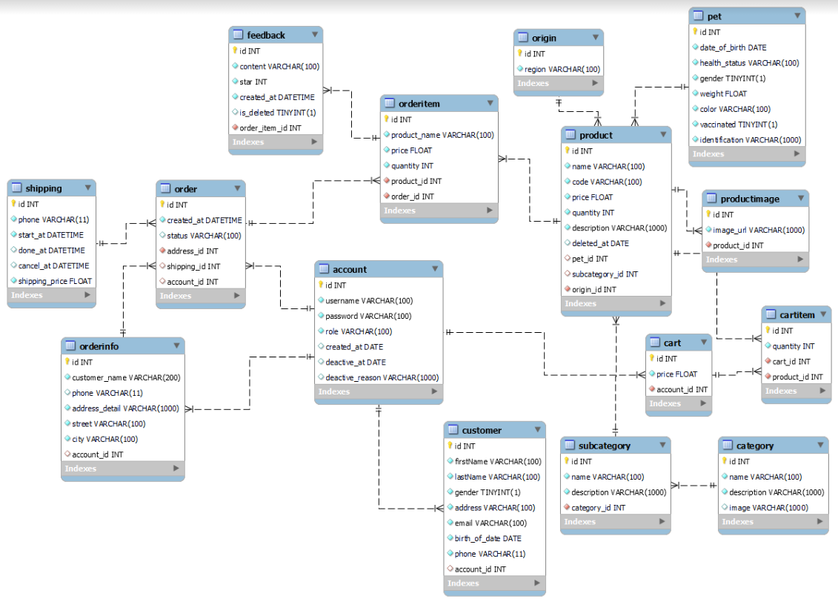

**Entities Description**

| **#** | **Entity** | **Description** |
| --- | --- | --- |
| 1 | account | The registered Users, Employee, Admin of the system |
| 2 | order | Contains information about order |
| 3 | orderinfo | Contains information about order and customer |
| 4 | orderitem | Contains information about product customer buy |
| 5 | shipping | Contains information about shipping status |
| 6 | feedback | Contains information about feedback of customer after bought |
| 7 | customer | Contains information about Users that have an account |
| 8 | product | Contains information about product |
| 9 | origin | Contains information about region of that product |
| 10 | pet | Contains information about pet |
| 11 | productimage | Contains images of each product |
| 12 | cart | Contains information about cart |
| 13 | cart item | Contains item in cart |
| 14 | subcategory | Contains information about subcategory |
| 15 | category | Contains information on subcategory and category |

## 

## 2.Manage account

#### a.Managed account

#### 

| **Use Case ID** | UC-01 | **Use Case Name** | Managed account |
| --- | --- | --- | --- |
| **Created By** |  | **Created Date** |  |
| **Primary Actor** | Admin | **Secondary Actor** | N/A |
| **Trigger** | Triggered when click on the button “Managed account” | | |
| **Description** | This function allows the admin to view, control all accounts in the system. | | |
| **Pre-conditions** | 1. Login the system with admin account 2. Click on the button “Managed account” | | |
| **Post-conditions** | Display all account of the system | | |
| **Normal Flow** | 1. View product at home pages 2. Click on “Managed account” | | |
| **Alternative Flow** | N/A | | |
| **Exceptions** | N/A | | |
| **Priority** | High | | |
| **Frequency of Use** | High | | |
| **Business Rules** | N/A | | |
| **Other Information** | N/A | | |

#### b.Add account

#### 

| **Use Case ID** | UC-02 | **Use Case Name** | Add account |
| --- | --- | --- | --- |
| **Created By** |  | **Created Date** |  |
| **Primary Actor** | Admin | **Secondary Actor** | N/A |
| **Trigger** | Click on the button “Add” | | |
| **Description** | This function allows the admin to add a new account for employees (shipper) into the system. | | |
| **Pre-conditions** | 1. Logged into the system with an admin account 2. Click on “Managed account” 3. Click on “Add” icon | | |
| **Post-conditions** | Successfully create a new account for another | | |
| **Normal Flow** | 1. Access website 2. Logged in the system with admin account 3. Click on “Managed account” button 4. Click on “Managed account” button | | |
| **Alternative Flow** | N/A | | |
| **Exceptions** | N/A | | |
| **Priority** | High | | |
| **Frequency of Use** | High | | |
| **Business Rules** | N/A | | |
| **Other Information** | N/A | | |

#### c.View account

#### 

| **Use Case ID** | UC-03 | **Use Case Name** | View account |
| --- | --- | --- | --- |
| **Created By** |  | **Created Date** |  |
| **Primary Actor** | Admin | **Secondary Actor** | N/A |
| **Trigger** | Triggered when click on the button “Managed account” | | |
| **Description** | Display accounts information of all actors | | |
| **Pre-conditions** | 1. Admin logged in the system 2. Click on “Managed account” button 3. Click on account card want to view | | |
| **Post-conditions** | Display information of the account | | |
| **Normal Flow** | 1. Admin logged in the system 2. Click on “Managed account” button 3. Click on account card want to view | | |
| **Alternative Flow** | N/A | | |
| **Exceptions** | N/A | | |
| **Priority** | High | | |
| **Frequency of Use** | High | | |
| **Business Rules** | N/A | | |
| **Other Information** | N/A | | |

#### d.Delete account

#### 

| **Use Case ID** | UC - 04 | **Use Case Name** | Delete account |
| --- | --- | --- | --- |
| **Created By** |  | **Created Date** | 15/2/2023 |
| **Primary Actor** | Admin | **Secondary Actor** | N/A |
| **Trigger** | Triggered when click on the button icon “trash bin” in “Managed account” | | |
| **Description** | Display “Confirm” to deactivate account from the system when click on “trash bin” icon | | |
| **Pre-conditions** | 1. Admin logged in the system 2. Click on “Managed account” button 3. Click on account card want to view | | |
| **Post-conditions** | Deactivate an account from the system | | |
| **Normal Flow** | 1. Admin logged in the system 2. Click on “Managed account” button 3. Click on “trash bin” icon in that account card want to deactivate | | |
| **Alternative Flow** | N/A | | |
| **Exceptions** | N/A | | |
| **Priority** | High | | |
| **Frequency of Use** | High | | |
| **Business Rules** | N/A | | |
| **Other Information** | N/A | | |

## 3.Manage cart

#### a.Create cart

| **Use Case ID** | UC - 05 | **Use Case Name** | Create cart |
| --- | --- | --- | --- |
| **Created By** | Bùi Doãn Đức Anh | **Created Date** | 15/2/2023 |
| **Primary Actor** | Customer, Viewer | **Secondary Actor** | N/A |
| **Trigger** | Click on the button icon “cart” in each product. | | |
| **Description** | Add a new product users may buy | | |
| **Pre-conditions** | Access the website and click icon “cart” each product want to add | | |
| **Post-conditions** | N/A | | |
| **Normal Flow** | 1. Access the website 2. Add product to cart by click that cart’s product | | |
| **Alternative Flow** | N/A | | |
| **Exceptions** | N/A | | |
| **Priority** | High | | |
| **Frequency of Use** | High | | |
| **Business Rules** | N/A | | |
| **Other Information** | N/A | | |

#### b.View cart

| **Use Case ID** | UC - 06 | **Use Case Name** | View cart |
| --- | --- | --- | --- |
| **Created By** | Bùi Doãn Đức Anh | **Created Date** | 15/2/2023 |
| **Primary Actor** | Customer, Viewer | **Secondary Actor** | N/A |
| **Trigger** | Click on button icon cart to view | | |
| **Description** | View what they add to cart before | | |
| **Pre-conditions** | Users must add product to cart before | | |
| **Post-conditions** | Display all product that add to cart beafore | | |
| **Normal Flow** | Click on button icon “cart” | | |
| **Alternative Flow** | N/A | | |
| **Exceptions** | N/A | | |
| **Priority** | High | | |
| **Frequency of Use** | High | | |
| **Business Rules** |  | | |
| **Other Information** | N/A | | |

#### c.Update cart

#### 

| **Use Case ID** | Uc - 07 | **Use Case Name** | Update cart |
| --- | --- | --- | --- |
| **Created By** | Bùi Doãn Đức Anh | **Created Date** | 15/2/2023 |
| **Primary Actor** | Customer, Viewer | **Secondary Actor** | N/A |
| **Trigger** | Click on button icon “cart” and add more or remove | | |
| **Description** | Add more or remove product from cart | | |
| **Pre-conditions** | Users must add at least one product to cart before | | |
| **Post-conditions** | Delete product add before or change the number of it | | |
| **Normal Flow** | Click on button icon “cart” | | |
| **Alternative Flow** | N/A | | |
| **Exceptions** | N/A | | |
| **Priority** | High | | |
| **Frequency of Use** | High | | |
| **Business Rules** | N/A | | |
| **Other Information** | N/A | | |

#### d.Clear cart

| **Use Case ID** | UC - 08 | **Use Case Name** | Clear cart |
| --- | --- | --- | --- |
| **Created By** | Bùi Doãn Đức Anh | **Created Date** | 15/2/2023 |
| **Primary Actor** | User | **Secondary Actor** | N/A |
| **Trigger** | Click on button “X” in Cart Icon at navigation. | | |
| **Description** | Remove all product from cart | | |
| **Pre-conditions** | Must have product in cart | | |
| **Post-conditions** | N/A | | |
| **Normal Flow** | 1. Go to View Cart 2. Click on button “X” to cancel | | |
| **Alternative Flow** | N/A | | |
| **Exceptions** | N/A | | |
| **Priority** | High | | |
| **Frequency of Use** | High | | |
| **Business Rules** |  | | |
| **Other Information** | N/A | | |

### 

## 4.Manage orders

#### a.Managed order

#### 

| **Use Case ID** | UC - 09 | **Use Case Name** | Managed order |
| --- | --- | --- | --- |
| **Created By** | Bùi Doãn Đức Anh | **Created Date** | 15/2/2023 |
| **Primary Actor** | Admin | **Secondary Actor** | Users |
| **Trigger** | Click on the button “Managed order” at navigation. | | |
| **Description** | Display all about order and status | | |
| **Pre-conditions** | Logged in the system with account of admin or employee | | |
| **Post-conditions** | Display the screen of all orders | | |
| **Normal Flow** | 1. Logged in the system 2. Click on the button “Managed order” | | |
| **Alternative Flow** | N/A | | |
| **Exceptions** | N/A | | |
| **Priority** | High | | |
| **Frequency of Use** | High | | |
| **Business Rules** |  | | |
| **Other Information** | N/A | | |

### 

#### b.Create order

#### 

| **Use Case ID** | UC - 10 | **Use Case Name** | Create order |
| --- | --- | --- | --- |
| **Created By** | Bùi Doãn Đức Anh | **Created Date** | 15/2/2023 |
| **Primary Actor** | Users | **Secondary Actor** | N/A |
| **Trigger** | Click on the button “Checkout” at cart | | |
| **Description** | Display form to fill and create an order | | |
| **Pre-conditions** | 1. Logged in the system 2. Have product at “cart” | | |
| **Post-conditions** | Submit an order | | |
| **Normal Flow** | 1. Add product before (after) logged in the system 2. Click on the button “Checkout” 3. Fill the form with information | | |
| **Alternative Flow** | N/A | | |
| **Exceptions** | N/A | | |
| **Priority** | High | | |
| **Frequency of Use** | High | | |
| **Business Rules** |  | | |
| **Other Information** | N/A | | |

### 

#### c.View order

#### 

| **Use Case ID** | UC - 11 | **Use Case Name** | View order |
| --- | --- | --- | --- |
| **Created By** | Bùi Doãn Đức Anh | **Created Date** | 15/2/2023 |
| **Primary Actor** | Users | **Secondary Actor** | N/A |
| **Trigger** | Click on the button “Managed order” | | |
| **Description** | Display all information contains order | | |
| **Pre-conditions** | 1. Logged in the system 2. Click on the button “Managed order” | | |
| **Post-conditions** | View all information contains order | | |
| **Normal Flow** | 1. Logged in the system 2. Click on the button “Managed order” | | |
| **Alternative Flow** | N/A | | |
| **Exceptions** | N/A | | |
| **Priority** | High | | |
| **Frequency of Use** | High | | |
| **Business Rules** |  | | |
| **Other Information** | N/A | | |

### 

#### d.Update order

#### 

| **Use Case ID** | UC - 12 | **Use Case Name** | Update order |
| --- | --- | --- | --- |
| **Created By** | Bùi Doãn Đức Anh | **Created Date** | 15/2/2023 |
| **Primary Actor** | Users | **Secondary Actor** | N/A |
| **Trigger** | Click on the button “Managed order” and then click on “Update” button | | |
| **Description** | Add or remove some product of order, Change number or address | | |
| **Pre-conditions** | 1. Logged in the system 2. Must have product in cart | | |
| **Post-conditions** | Update successfully orders | | |
| **Normal Flow** | 1. Logged in the system 2. Must have product in cart | | |
| **Alternative Flow** | N/A | | |
| **Exceptions** | N/A | | |
| **Priority** | High | | |
| **Frequency of Use** | High | | |
| **Business Rules** |  | | |
| **Other Information** | N/A | | |

### 

#### e.Cancel order

#### 

| **Use Case ID** | UC - 13 | **Use Case Name** | Cancel order |
| --- | --- | --- | --- |
| **Created By** | Bùi Doãn Đức Anh | **Created Date** | 15/2/2023 |
| **Primary Actor** | Users | **Secondary Actor** | N/A |
| **Trigger** | Click on the button “Managed order” and then click on “Cancel” button | | |
| **Description** | Cancel the order | | |
| **Pre-conditions** | Must submit order before | | |
| **Post-conditions** | Successfully cancel an order | | |
| **Normal Flow** | 1. Logged in the system 2. Click on “Managed orders” button 3. Click on “Cancel” button and confirm | | |
| **Alternative Flow** | N/A | | |
| **Exceptions** | N/A | | |
| **Priority** | High | | |
| **Frequency of Use** | High | | |
| **Business Rules** |  | | |
| **Other Information** | N/A | | |

### 

## 5.Manage personal profile

#### a.View personal profile

#### 

| **Use Case ID** | UC - 14 | **Use Case Name** | View personal profile |
| --- | --- | --- | --- |
| **Created By** | Bùi Doãn Đức Anh | **Created Date** |  |
| **Primary Actor** | Users | **Secondary Actor** | N/A |
| **Trigger** | Click on the button “Profile” | | |
| **Description** | Display all information’s user | | |
| **Pre-conditions** | Logged in the system | | |
| **Post-conditions** | Display all information of that actor | | |
| **Normal Flow** | 1. Logged in the system 2. Click on the “Profile” button | | |
| **Alternative Flow** | N/A | | |
| **Exceptions** | N/A | | |
| **Priority** | High | | |
| **Frequency of Use** | High | | |
| **Business Rules** |  | | |
| **Other Information** | N/A | | |

### 

#### b.Update personal profile

#### 

| **Use Case ID** | UC - 15 | **Use Case Name** | Update personal profile |
| --- | --- | --- | --- |
| **Created By** | Bùi Doãn Đức Anh | **Created Date** |  |
| **Primary Actor** | Users | **Secondary Actor** | N/A |
| **Trigger** | Click on the button “Update” | | |
| **Description** | Display form to fill and update profile | | |
| **Pre-conditions** | Logged in the system | | |
| **Post-conditions** | Successfully update self-information | | |
| **Normal Flow** | 1. Logged in the system 2. Click on “Profile” button 3. Click on “Update” button | | |
| **Alternative Flow** | N/A | | |
| **Exceptions** | N/A | | |
| **Priority** | High | | |
| **Frequency of Use** | High | | |
| **Business Rules** |  | | |
| **Other Information** | N/A | | |

### 

## 6.Common feature

#### a.View home page

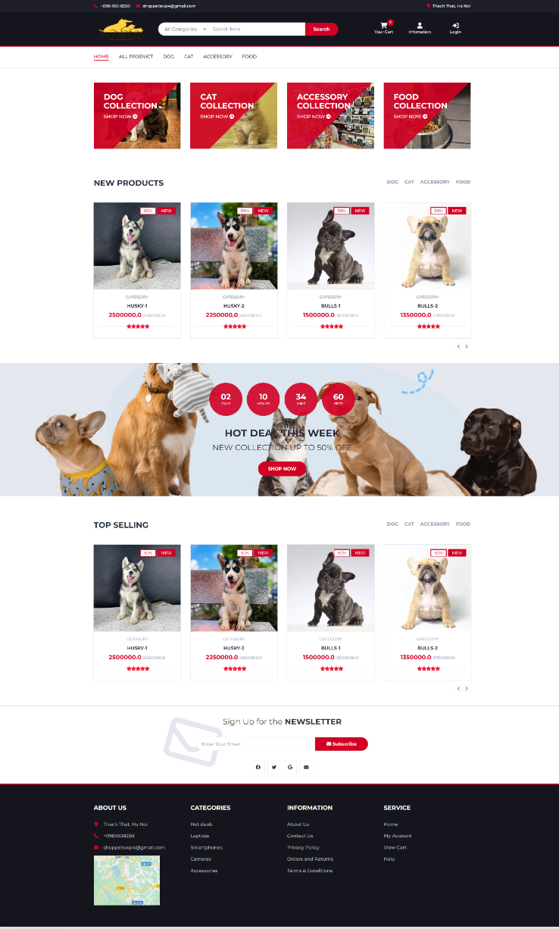

| **Use Case ID** | UC - 16 | **Use Case Name** | Home Page |
| --- | --- | --- | --- |
| **Created By** | Khuất Đình Sáng , Truong Anh Ky | **Created Date** | 15/2/2023 |
| **Primary Actor** | Users | **Secondary Actor** | Admin |
| **Trigger** | This function is triggered when the user visits the website or the system homepage | | |
| **Description** | To navigate the home page of the website and find the information or services they are looking for | | |
| **Pre-conditions** | The website is accessible and the user has a device with an internet connection | | |
| **Post-conditions** | The website visitor may continue to explore the website or leave the site if they have found what they were looking for. | | |
| **Normal Flow** | 1.The website visitor enters the URL of the website into their web browser.  2. The homepage is loaded and displays various information, including the website’s name, logo, and navigation menu.  3.The website visitor selects a navigation option, such as clicking a link or using a menu, to access additional pages or features of the website. | | |
| **Alternative Flow** | If the website is experiencing technical issues, such as slow loading times or broken links, the website visitor may not be able to access certain pages or features. In this case, they can try again later or contact the website owner for assistance. | | |
| **Exceptions** | N/A | | |
| **Priority** | High | | |
| **Frequency of Use** | High | | |
| **Business Rules** |  | | |
| **Other Information** | N/A | | |

#### b.Register

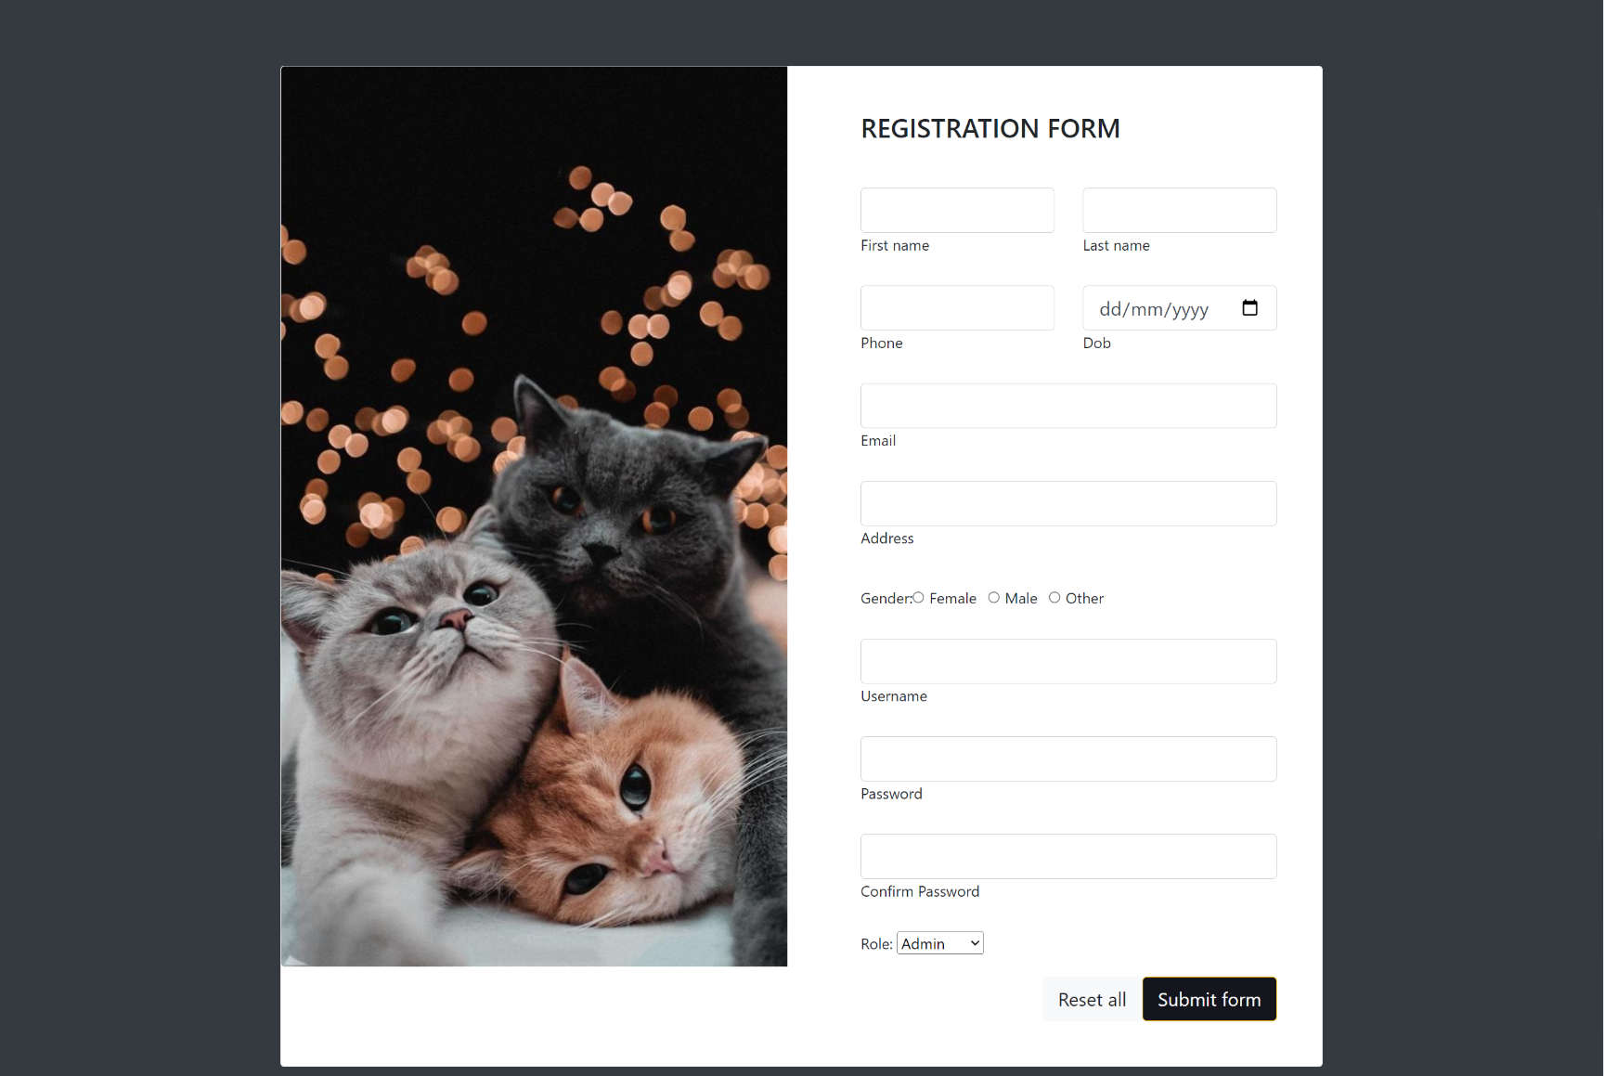

| **Use Case ID** | UC - 17 | **Use Case name** | Register |
| --- | --- | --- | --- |
| **Created By** | Nguyễn Thành Long | **Created Date** | 3/2/2023 |
| **Primary Actor** | Customer | **Secondary Actor** | N/A |
| **Description** | Check email, Check username, Register Account for User | | |
| **Trigger** | Click on the button “Register” on the screen. | | |
| **Pre-conditions** | The user must have a valid email address and phone number to create an account.  The user must have access to the internet and a compatible device to access the registration page.  The user must have a unique username that has not been used by any other user in the system. | | |
| **Post-conditions** | The user's registration information is stored securely in the database.  The user is automatically logged in to the system and redirected to the home page.  The user's account is activated and can be used to access all features of the system.  If the user's registration information is invalid or incomplete, an error message is displayed, and the user is prompted to correct their information.  The system checks that the user's email address and username are unique and have not been used to create another account.  The registration form provides clear instructions and guidance for the user to complete the registration process.  The user can easily access and update their registration information at any time from their account settings. | | |
| **Normal Flow** | The user accesses the registration page and is presented with a form to fill out.  The user enters their personal information, such as their name, email address, and date of birth, into the appropriate fields.  The user chooses a unique username and password and enters them into the appropriate fields. The user is notified if the chosen username is already taken or if the password does not meet the minimum security requirements.  The user submits the registration form and the system verifies that all required fields are filled out correctly.  The system checks the database to ensure that the chosen username and email address are not already in use.  If the username and email are unique, the system creates a new account for the user and saves their information to the database.  The user is redirected to the login page and prompted to log in with their newly created account. | | |
| **Alternative Flow** | User enters their email address and password, but the password doesn't meet the minimum complexity requirements (e.g. length, special characters).  User fills out the registration form, but their browser session expires or they lose internet connection before submitting.  User fills out the registration form, but some required fields are missing or contain invalid data. The system displays an error message and highlights the fields that need to be corrected. The user makes the necessary changes and resubmits the form. | | |
| **Exceptions** | N/A | | |
| **Priority** | High | | |
| **Frequency of Use** | High | | |
| **Business Rules** |  | | |
| **Other Information** | N/A | | |

#### c.Login

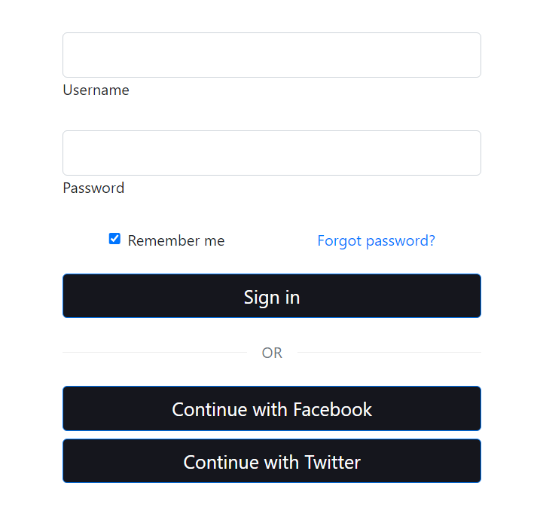

| **Use case ID** | UC - 18 | **Use case name** | Login |
| --- | --- | --- | --- |
| **Created By** | Phạm Minh Hoàng | **Created Date** | 15/2/2023 |
| **Primary actor** | Admin, Employee | **Secondary actor** | Users |
| **Trigger** | Triggered when an actor clicks on the “Login” button. | | |
| **Description** | Actors use this function to login with their account | | |
| **Pre-conditions** | 1. Actors are not log in 2. Actors have an own account | | |
| **Post-conditions** | 1. Actors logged in the systems 2. The system save actor’s account on session | | |
| **Normal Flow** | 1. Access website feature of actor’s role without log in status (action) 2. Click on “Login” button in navbar at header (action) 3. After click on “Login” button in header navbar, System will send direct to login page and display form login (resp) 4. Fill username and password (action) 5. Click on “Login” button under text box to submit data (action) 6. After submit date and login successful send direct to home page (resp) | | |
| **Alternative Flow** | N/A | | |
| **Exceptions** | * **E1: If actors click on  button (after step 3)**   Send direct to previous page without any change   * **E2 : If don’t fill full information (after step 5)**   Pop up message “Login fail” | | |
| **Priority** | High | | |
| **Frequency of Use** | Normal | | |
| **Business Rules** | N/A | | |
| **Other Information** | N/A | | |

#### d.Logout



| **Use case ID** | UC - 19 | **Use case name** | Logout |
| --- | --- | --- | --- |
| **Created By** | Phạm Minh Hoàng | **Created Date** | 15/2/2023 |
| **Primary actor** | Admin, Employee | **Secondary actor** | Users |
| **Trigger** | When the actor clicks on the “Logout” button. | | |
| **Description** | Actors use this function to logout their account out of system | | |
| **Pre-conditions** | 1. Actor are logged in system | | |
| **Post-conditions** | 1. Actors logout their account out of system 2. Successful logout and end actor’s session | | |
| **Normal Flow** | 1. Actor click on “Logout” button at header (action) 2. System will send direct to home page (resp) | | |
| **Alternative Flow** | N/A | | |
| **Exceptions** | N/A | | |
| **Priority** | High | | |
| **Frequency of Use** | Normal | | |
| **Business Rules** | N/A | | |
| **Other Information** | N/A | | |

#### e.Forgot password

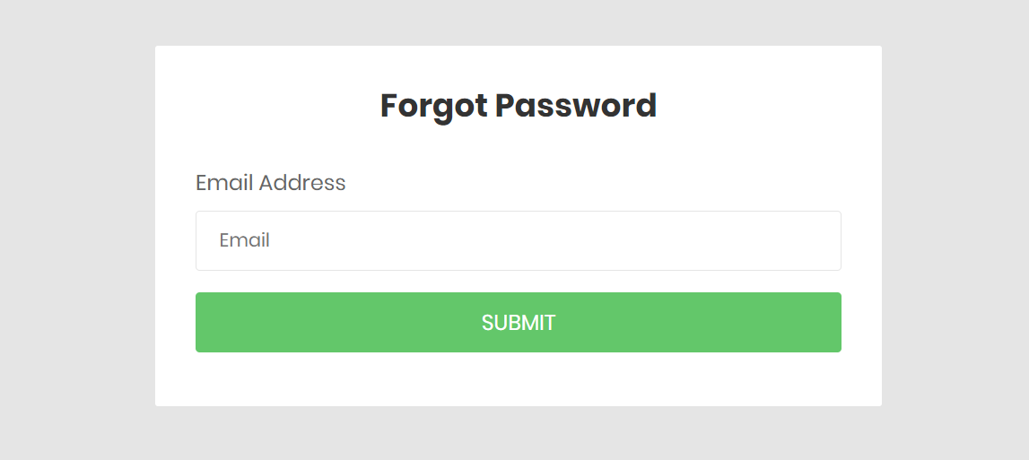

| **Use case ID** | UC - 19 | **Use case name** | Forgot Password |
| --- | --- | --- | --- |
| **Created By** | Khuất Đình Sáng | **Created Date** | 15/2/2023 |
| **Primary actor** | Admin, Employee | **Secondary actor** | Users |
| **Trigger** | This function is triggered when the user clicks “Forgot password” | | |
| **Description** | To reset a forgotten password and regain access to the user's account. | | |
| **Pre-conditions** | The user has an account with the system and is unable to login due to a forgotten password. | | |
| **Post-conditions** | Successfully reset password | | |
| **Normal Flow** | 1.The user clicks on the "Forgot Password" link on the login page.  2. The system presents a page for the user to enter their registered email associated with the account.  3.The user enters their registered email address or username and clicks on the "Reset Password" button.  4. The system verifies the email address and sends a code to the registered email address.  5. the user will go to the email to get that code and then enter it in input  6. The system presents a page for the user to enter a new password.  7. The user enters and confirms the new password and clicks on the "Submit" button.  8. The system updates the user's account with the new password and redirects the user to the login page.  9. The user logs in with the new password and regains access to their account. | | |
| **Alternative Flow** | 1.If the user enters an invalid email address or username, the system displays an error message and prompts the user to enter valid details.  2.If the user does not receive the password reset email, they may need to check their spam folder or contact the system's support team for assistance. | | |
| **Exceptions** | N/A | | |
| **Priority** | Medium | | |
| **Frequency of Use** | rarely | | |
| **Business Rules** |  | | |
| **Other Information** | N/A | | |

#### f.Product detail

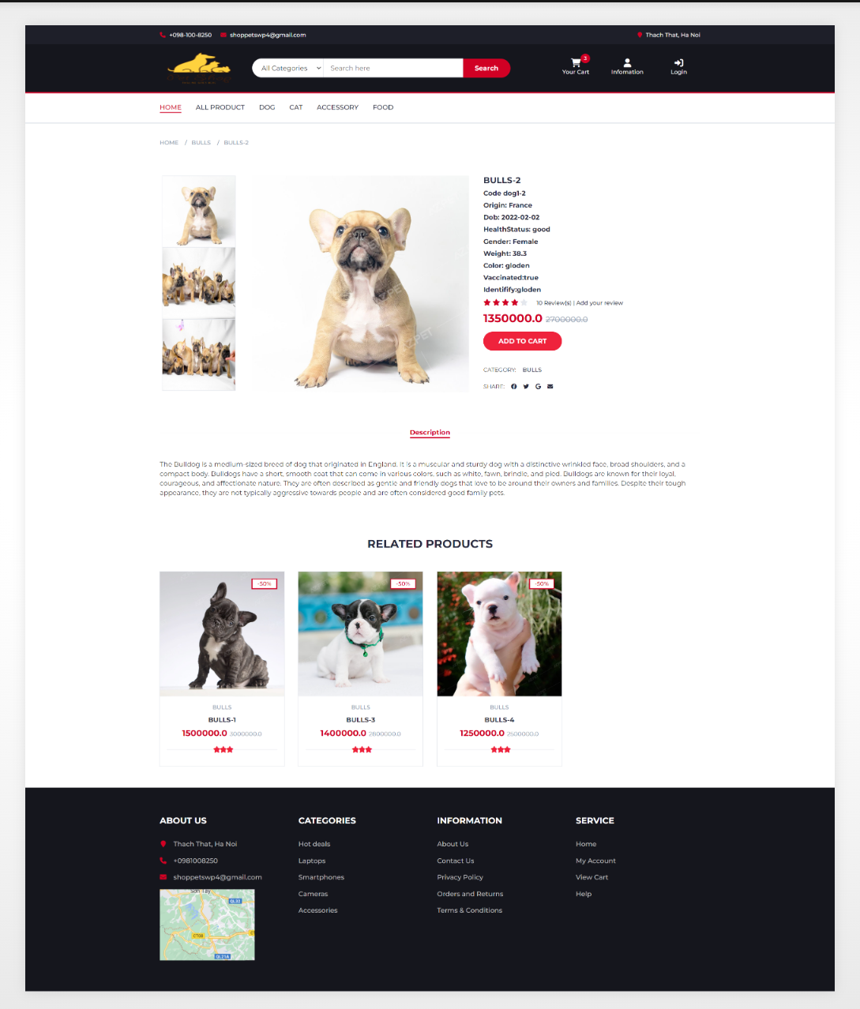

| **Use case ID** | UC - 20 | **Use case name** | Product detail |
| --- | --- | --- | --- |
| **Created By** | Truong Anh Ky | **Created Date** | 15/2/2023 |
| **Primary actor** | Admin, Employee | **Secondary actor** | Users |
| **Trigger** | When the actor clicks on a product at home page | | |
| **Description** | View all contains information about that product | | |
| **Pre-conditions** | N/A | | |
| **Post-conditions** | N/A | | |
| **Normal Flow** | 1. Access the website 2. Click on a product | | |
| **Alternative Flow** | N/A | | |
| **Exceptions** | N/A | | |
| **Priority** | High | | |
| **Frequency of Use** | Normal | | |
| **Business Rules** | N/A | | |
| **Other Information** | N/A | | |

#### g.Search

| **Use case ID** | UC - 21 | **Use case name** | Search |
| --- | --- | --- | --- |
| **Created By** | Truong Anh Ky | **Created Date** | 15/2/2023 |
| **Primary actor** | Admin, Employee | **Secondary actor** | Users |
| **Trigger** | When the actor access the website | | |
| **Description** | Searching by product product or category | | |
| **Pre-conditions** | N/A | | |
| **Post-conditions** | N/A | | |
| **Normal Flow** | 1. Access the website 2. Click on the button under search bar to choose option search 3. Fill search bar 4. Click on search | | |
| **Alternative Flow** | N/A | | |
| **Exceptions** | N/A | | |
| **Priority** | High | | |
| **Frequency of Use** | Normal | | |
| **Business Rules** | N/A | | |
| **Other Information** | N/A | | |

# IV. Non-Functional Requirements

## 1.External Interface

#### a.User Interfaces

UI-1: The user can log in the system as Admin, Employee or Customer role.

UI-2: The GUI is suitable for display on the computer.

UI-3: The layout of the screen is streamlined, easy to operate, and implemented for the user.

UI-4: Use icons to provide visual insights to users.

UI-5: The text colour should be black except for some special texts.

UI-6: Tables appearing on the system must have filter and sort functions.

UI-7: Buttons, links, checkboxes, radio buttons are easy to click to use.

#### b.Hardware Interfaces

No hardware interfaces have been identified.

#### c.Communication Interfaces

CI-1: The system shall send an email to the user’s email to get a new password when the user forgot their account password.

CI-2: Users use a mouse to communicate with applications to handle functions that use need.

CI-3: The system shall display a text message to notify about the result of the function that the user performed.

## 2.Quality Attributes

#### a.Usability

* The language is considered as a world language (English) with simple words
* The Front-end web application should support Chrome browsers.
* The function is divided into menu items for easier access.

#### b.Availability

* N/A

#### c.Performance

* All pages have loading speed less than 3 seconds on average

#### d.Security

* N/A

#### e.Safety

* The system shall not spread viruses into the devices of users.
* The system shall not include any harm information for users.
* The system shall notify the user to confirm when performing any function that affects the database.

#### f.Support Documents

* Class libraries, framework, etc shall be described

# V. Requirements Appendix

## 1.Business Rules

| **ID** | **Rule Definition** |
| --- | --- |
| BR-01 | Only verified users can log in successfully and access the system |
| BR-02 | Users only can access information that belongs to their own, except admin. |
| BR-03 | Employee only login with an account that is provided by admin |
| BR-04 | Each user has exactly one role. |
| BR-05 | Each email is only registered for one user. |
| BR-06 | Email must be the right format: “abc123@example.com”. |
| BR-07 | The username must be unique. |
| BR-08 | Passwords must be encrypted. |
| BR-09 | When registering or changing a password, the user must enter the password twice. |
| BR-10 | The date of birth must be before the current time. |
| BR-11 | All lists must be displayed with the pagination. |
| BR-12 | The admin is only allowed to reset password when the admin receives a request by the user. |
| BR-13 | Only create order when have product in cart and logged in the system |
| BR-14 | Each pet only have only one |

## 2.Common Requirement

* The pop-up form is used for functions such as viewing, adding, editing, and deleting.
* Account in the database is not deleted when using the delete function; instead, it is changed from active to inactive.
* The system must display the result of performing a data-related function at the end of the function.

## 3.Application Messages List

| **ID** | **Type** | **Context** |
| --- | --- | --- |
| M-01 | In red, under the text box | The user does not select or enter required field |
| M-02 | In red, under the text box | The user entered an email invalid |
| M-03 | In red, under the text box | The user entered an existing email in the database |
| M-04 | In red, under the text box | The user entered an existing username in the database |
| M-05 | In red, under the text box | The user entered a username invalid or wrong form |
| M-06 | In red, under the text box | The user entered password invalid |
| M-07 | In red, under the text box | The user entered phone invalid |
| M-08 | In red, under the text box | The user entered a password has length less than 8 characters or greater than 20 characters |
| M-09 | In red, under the text box | The user entered a re-password does not match with password |
| M-10 | In green, on alert | User edited account successfully |
| M-11 | In green, on alert | User reset password of account successfully |
| M-12 | In green, on alert | Create order successful |

# VI. Nhaps

## 2. System Functions

#### a. Screen Flow

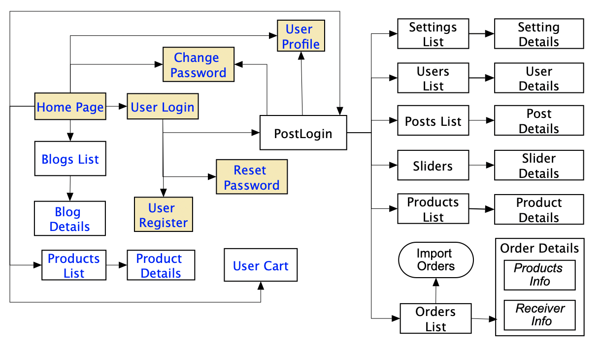

#### d. Non-Screen Functions

*[Provide the descriptions for the non-screen system functions, i.e batch/cron job, service, API, etc.]*

| **#** | **Feature** | **System Function** | **Description** |
| --- | --- | --- | --- |
| 1 | <<Feature Name>> | <<Function Name1>> | <<Function Name1 Description>> |
| 2 | … |  |  |

| **Date** | **A* M, D** | **In charge** | **Change Description** |
| --- | --- | --- | --- |
| 5/1/2023 | A | Create new SRS | Create new |
|  | A | Thành Long | User Register |
|  | A | Minh Hoàng | Login |
|  | A | Minh Hoàng | Logout |
|  | A | Đình Sáng | Forgot Password |
|  | A | Thành Long | Change Password |
|  | A | Anh Kỳ | Store,View, Filter, Search Product |
|  | A | Minh Hoàng | Listing Category and SubCategory |
|  | A | Đình Sáng | Home Page |
|  | A | Minh Hoàng | Listing Product |
|  | A | Đình Sáng | CRUD (create read, update, delete) product |
|  | A | Đình Sáng | View, Filter, Search Order |
|  | M | Anh Kỳ | Product Detail, List Product Detail |

*A - Added M - Modified D - Deleted